|  |
| --- |
| Team 2 |
| Weekly Report |
| Task Time Management System |

|  |
| --- |
| Carla Machado  02-03-2013 |

**Team Members:**

Carla Machado

David João

Filipe Brandão

João Girão

João Martins

Mário Oliveira

Rui Ganhoto

**Week 2**, 25th of Month to 4th of Month

Content

1. Week Activities 1

1.1. Work Executed 1

1.2. Achievements 1

2. Impediments 1

3. Plans For Next Week 1

4. Progress 1

4.1. Earned value and/or Gantt Image 1

4.2. Effort by task 2

4.3. Individual effort 2

5. Individual log 2

**Images**

**Não foi encontrada nenhuma entrada do índice de ilustrações.**

**Tables**

Table 1: List of Contribuitors ii

Table 2: Version history ii

Table 3: Log of individual effort 2

|  |  |  |  |
| --- | --- | --- | --- |
| **Authors and Contributors** | | | |
| **Date** | **Name** | **Contacts** | **Contribution** |
| 02-03-2013 | Carla Machado | a21170460@alunos.isec.pt | Author |
| 03-03-2013 | Filipe Brandão | a21180276@alunos.isec.pt | Contributor |
|  |  |  |  |
|  |  |  |  |

Table 1: List of Contributors

|  |  |  |  |  |  |
| --- | --- | --- | --- | --- | --- |
| **Revision History** | | | | | |
| **Date** | **Description** | **Author** | **Version** | **Approvers** | **State** |
| 02-03-2013 | Creation of first draft | Carla Machado | 0.1 |  | Draft |
| 03-03-2013 | Continuation of first draft | Filipe Brandão | 0.2 |  | Draft |
|  |  |  |  |  |  |
|  |  |  |  |  |  |
|  |  |  |  |  |  |

Table 2: Version history

# Week Activities

# Work Executed

* Started building dashboard;
* Vision and Scope (first draft);
* Processes listing was reviewed;
* Estimated processes definition;
* Next Progress Meeting was planned;
* Documents Management Process was reviewed and corrected.

# Impediments

None identified.

# Plans For Next Week

* Review Documents Management Process again.

# Progress

# Individual effort

|  |  |
| --- | --- |
| **Name** | **Effort(hours)** |
| Carla Machado | 7.5 |
| David João | 5.5 |
| Filipe Brandão | 7 |
| João Girão | 5.5 |
| João Martins | 6 |
| Mário Oliveira | 7 |
| Rui Ganhoto | 5.5 |

Table 1: Log of individual effort

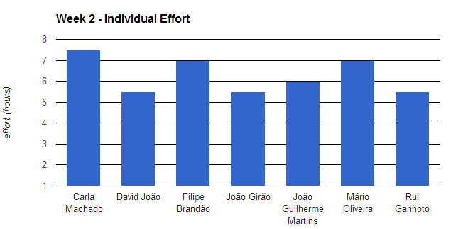

# Individual log

**Carla Machado - Tasks done:**

* Initial Discussion
* Document Management Process
* Process analysis
* Processes discussion and prioritization
* Estimate Process definition
* Process list and planning document
* Vision and Scope document
* Weekly report

**David João - Tasks done:**

* Study and planning of the Project Planning and Risk Management Processes
* Reordering of the processes list
* Discussion about processes and their order
* Discussion and participation in the first draft of the Vision and Scope

**Filipe Brandão - Tasks done:**

* Producing dashboard
* Reviewing documents management process
* Estimating Project Planning Process and Review Process
* Discussion about processes and their order

**João Girão - Tasks done:**

* Study and planning the Assessment and Control Process and Requirement Analysis Process for estimate
* Research programs and information on task times and elaboration the first draft Vision and Scope (v0.1)
* Discussion about processes and their order
* Discussion and Conclusion the first draft of document Vision and Scope

**João Martins – Tasks done:**

* Study of Review Processes and study of Project Planning Processes
* Reviewing process planning
* Discussion of the project processes

**Mário Oliveira - Tasks done:**

* Initial discussion.
* Document Management Process
* Document Measures Creation and Update effort functions of all spreadsheets
* Discussion about processes and their order
* Review Processes and Verification & Validation Process study

**Rui Ganhoto - Tasks done:**

* Work planning and Discussion
* Process study and analysis
* Processes Listing Discussion
* Agenda
* Vision and Scope document